All questions are worth 1 point unless otherwise stated.
- [The Dress] In 2015 there was a viral story about the colors of a dress in a picture. Some saw the colors as blue and black and others saw them as white and gold. Suppose you take a sample of 100 people and ask them which of the two color combinations they think the dress is. You want to see whether a majority think that the dress is blue and black (the actual colors of the dress). Also suppose you find that 57 out of your sample of 100 correct identified the colors as blue and black. To conduct a simulation of this study, you could flip a coin [BLANK] times and repeat that process [BLANK] times.
Fill in the two blanks, in their respective order:
  - 100; 1,000
  - 1,000; 100
  - 57; 1,000
  - 1,000; 57
- [Buttered Toast] If you drop a piece of buttered toast on the floor, is it just as likely to land buttered side up as buttered side down? It sure seems like mine always lands buttered side down! Suppose that 7 of the last 10 times I dropped toast it landed buttered side down. In order to carry out a statistical analysis, the One Proportion applet was used to see if my toast fell buttered side down a majority (more than 50%) of the time. Use the dotplot generated by the applet to answer the following questions.
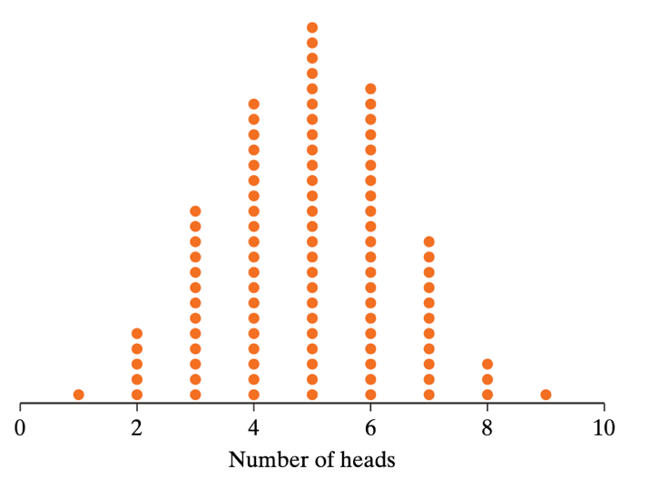
  - What does each dot represent in terms of dropped toast and buttered side down?
  - At what number is the dotplot centered? Could you have determined that before running the applet simulation? Why or why not?
  - Based on 7 of the last 10 slices of toast landing buttered side down and the above dotplot, are you convinced that the long-run proportion of times my toast lands buttered side down is greater than 50%? Explain how you are deciding.
  - Does this prove that my long-run proportion of dropping toast buttered side down is 50%?

- [Tea, 2 pts] A famous statistical study involves a woman who claimed to be able to tell whether tea or milk was poured first into a cup. She was presented with eight cups containing a mixture of tea and milk, and she correctly identified which had been poured first for all eight cups.
  - Identify the observational units and variable in this study.
  - Identify the sample size for the study, and the observed value of the statistic.
  - Is it possible the woman could get all eight correct if she were randomly guessing with each cup? (Answer for now based on your intuition, without doing any analysis.)
  - Describe how you can use a coin to address the question “Is it unlikely that the woman could get all eight correct if she were randomly guessing with each cup?” Be sure to include details such as how many times you would toss the coin and why; what would “heads” and “tails” stand for; what you would record after each set of coin tosses; how many times you would repeat this process. Also, how is this repeated coin tossing going to help you address the question?
  - Now use an applet simulation to address the question “Is it unlikely that the woman could get all eight correct if she were randomly guessing with each cup?” Then explain how your answer follows from your simulation results.
  - Based on your simulation analysis, would you conclude that the woman’s result produces strong evidence that she is not guessing as to whether milk or tea was poured first? Also explain the reasoning process behind your answer.
  - Is your result in (f) statistically significant or is it plausible she is just guessing?
- [NBA Ref] In 2007, NBA referee, Tim Donaghy was suspected of collaborating with a bookie to fix games in which he was refereeing. To help fix a game, a referee could call more fouls on one team which would allow the other team to score more points. If gamblers knew of this fix before the game, they would bet on the team that would have fewer called fouls to win (the one the referee was favoring). There were 40 games in which the referee and the bookie were suspected of collaborating. In these 40 games Donaghy's foul calls favored the team that received the heavier betting 28 times. We will assume there should be no relationship between fouls called on a team and heavy betting on the opposing team. Therefore, just by chance, we would expect about half the time Donaghy's foul calls would favor the team that received the heaviest betting. We want to determine whether assuming the chance model is true, it is very unlikely Donaghy's foul calls would favor the team that received heavier betting 28 out of 40 .
  - Describe how you could use coins to simulate the chance model. Give the number of coins you would use and what each side of the coin represents.
  - Use the One Proportion applet to answer the question, "If the chance model is true, how likely is it that Donaghy's foul calls would favor the team that received heavier betting 28 out of 40 times? Explain how you determined your answer based on the results in the applet.
- [Dice Roll] In rolling a fair six-sided die twice, the event of getting a 2 on the first roll and the event of getting a 4 on the second roll are:
  - Independent.
  - Disjoint. (AKA mutually exclusive!)
  - Neither independent nor disjoint.
  - Both independent and disjoint.
  - None of the above.
- [Independence] If two events, A and B, are independent, then which of the following must be true? (There may be more than one correct answer.)
  - Events A and B will never occur at the same time.
  - P(A|B) = P(A)
  - P(A|B) = P(B)
  - P(B|A) = P(B)
  - P(B|A) = P(A)
  - P(A and B) = 0
  - P(A and B) = P(A) × P(B)
- [Probabilities] Given that P(A) = 0.80, P(B) = 0.50, and P(A and B) = 0.40, answer the following questions.
  - What is P(A|B)?
  - What is P(B|A)?
  - What is P(A or B)?
  - Are events A and B independent? Explain.
  - Try and Venn diagram for events A and B and include the probabilities for each area.
- [Instagram and Facebook] As estimated by the Pew Research Center in 2016, the probabilities associated with a randomly chosen American adult using Facebook and Instagram are shown in the following two-way table.
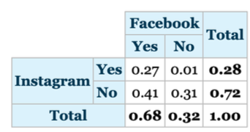
- Use the numbers in the table to construct the Venn diagram for these probabilities.
- What is the probability a randomly chosen American adult uses Facebook given he or she uses Instagram?
- What is the probability a randomly chosen American adult uses Instagram given he or she uses Facebook?
- What is the probability a randomly chosen American adult uses Facebook or Instagram?
- [Instagram and Twitter] As estimated by the Pew Research Center in 2016, the probability a randomly chosen American adult uses Instagram is 0.28, the probability a randomly chosen American adult uses Twitter is 0.21, and the probability a randomly chosen American adult uses Instagram given that he or she uses Twitter is 0.65.
- Using the Pew Research estimates, complete the following two-way table of probabilities (re-draw the table onto your answer sheet).
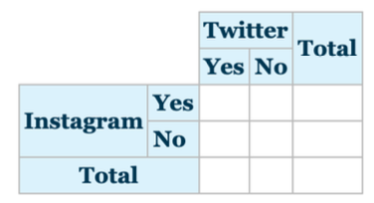
- What is the probability a randomly chosen American adult uses Twitter given he or she uses Instagram?
- What is the probability a randomly chosen American adult uses both Twitter and Instagram?
- What is the probability a randomly chosen American adult uses neither Twitter nor Instagram?

